Abstract
Cooperative 3D printing offers unique opportunities for the manufacturing of large-scale structures by integrating multiple printing heads to facilitate fast, multi-material, or multi-resolution printing. However, most existing cooperative strategies rely on decomposing the part into subdomains that are assigned to individual heads, which alters inter and intra layer gap times and introduces weak interfaces at decomposition boundaries. These effects change the age of the material at bonding, the stress distribution in the fresh material, and the resulting mechanical performance and risk of early age collapse. In this work, a novel decomposition-free Synchronous Multi-Layer Printing (SMLP) strategy is proposed. In SMLP each head prints an entire layer rather than a segment, and the heads operate with a controlled time shift so that consecutive layers are deposited with nearly uniform age of material along their length. This approach combines the mechanical advantages of single-head approaches with the build time efficiencies of multi-head systems. We first implement SMLP on a dual head FDM system and perform tensile and tear tests on PLA walls over a range of printing speeds and spans, comparing SMLP to conventional bi directional single head printing. These experimental results indicate that SMLP delivers superior interlayer tensile strength compared to decomposition-based strategies while preserving tear resistance. To assess the implications for large scale concrete printing, we then formulate an analytical model for extrusion based additive manufacturing that couples a time dependent yield stress law with the shear stress distribution in growing walls for SMLP, decomposition based multi head printing, and bi directional single head printing. The model predicts the onset of collapse as the time when the maximum shear stress exceeds the local yield stress and is used to conduct a parametric study over initial yield stress, printing speed, layer height, and wall length. The results indicate that SMLP not only reduces build time by approximately 24 percent relative to single head printing, but also increases the number of layers that can be printed before collapse by roughly 100 to 300 percent compared with decomposition based multi head strategies. Together, the experiments and models provide a unified framework for designing cooperative printing strategies that improve both productivity and structural integrity in large scale additive manufacturing.
Keywords: Cooperative 3D printing, Multi-head printing; Stress analysis; Analytical modeling; Part decomposition

Introduction
Large-scale additive manufacturing (AM) is gaining popularity among researchers and industry professionals for autonomous fabrication of large components such as full-size prototypes of submarine hulls and multi-story buildings [1,2]. It opens new avenues for building infrastructures in harsh environments or in space with minimal to no human involvement. Existing commercially available large-scale 3D printers [3,4] are capable of working with a diverse range of materials, including composites, cementitious materials, and metals. More recently, cooperative 3D printing involving robot swarms or teams of robots has demonstrated increased mobility and flexibility compared to traditional gantry-based systems, expanding applications within AM [5,6]. The adoption of multiple print heads in cooperative 3D printing enables the manufacturing process to be decomposed into smaller tasks that can be performed in parallel, leading to higher efficiency and faster build speeds [7]. Moreover, it enables the realization of functionally-graded, multi-material, and/or multi-resolution parts for enhanced properties and performance [8,9]. However, multi-head 3D printing introduces complexities, as various print strategies, parameters, and paths for different heads affect the inter-/intra-layer gap time, bonding/fusion extent, and stress distribution which ultimately impact the quality, strength, and lifespan of the printed structure.
Traditionally, multi-head printing has relied on decomposing a part into sub-sections, with each print head working on a distinct sub-part for cooperative 3D printing [10,11]. This structural decomposition, however, often leads to bonding issues at the intersections between sub-parts, compromising the structural integrity and dimensional accuracy of the final product [12]. To address these issues, various solutions, including angular decomposition strategies and non-flat interfaces based on topological interlocking geometries, have been proposed to improve bonding at sub-part boundaries [13,14]. Despite these advances, these approaches still face challenges in achieving seamless, non-decomposed structures that often fail to meet the structural quality of single-head printed parts as shown in Figure 1.
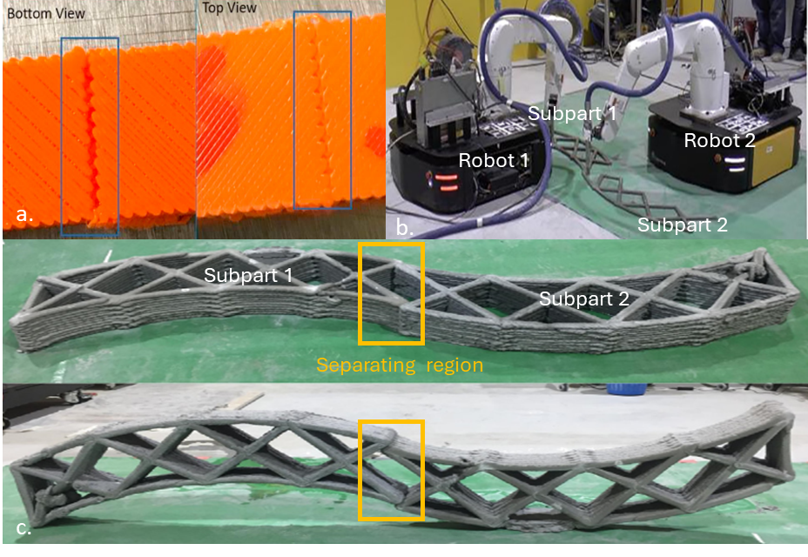
Figure 1. Illustrative examples of the inferior bonding and quality at decomposition boundary in existing multi-head cooperative printing scenarios, potentially leading to points of structural failure: a. Extrusion-based polymer cooperative printing [13], b and c. Extrusion-based concrete cooperative printing [15]
These limitations indicate that current multi-head approaches mainly improve productivity at the expense of structural performance. There is little guidance on how cooperative strategies should be designed so that they preserve, or even enhance, the mechanical integrity achieved by conventional single-head printing [16] . In particular, there is a lack of studies that connect multi-head toolpaths and inter-layer gap times to stress evolution and failure in fresh cementitious materials, which is essential for safe scaling to large structural components [17,18].To address this challenge, this study introduces and explores an innovative decomposition-free multi-head cooperative printing strategy named synchronous multi-layer printing (SMLP). The SMLP strategy assigns each layer to an individual print head, requiring the entire layer to be printed by the same head without the need for part decomposition, and enabling the synchronous printing of consecutive layers with a controlled time delay as illustrated in Figure 2. Few researchers have defined the traditional decomposition-based multi-head strategies as “concurrent” or “simultaneous” 3D printing, where multiple heads print different segments of the same layer concurrently [15]. However, this is different from our proposed strategy, in which multiple heads are simoultanously printing consequtive layers. The SMLP approach is designed to enhance printing efficiency typical of multi-head systems while retaining the mechanical integrity advantages characteristic of a single-head approach. .
To evaluate the effectiveness of the SMLP strategy, we perform a comparative study against traditional decomposition based multi head printing and bi directional single head printing. First, we design a systematic experimental campaign on PLA tensile and tear specimens printed on a modified independent dual extruder FDM machine. This setup enables direct measurement of how SMLP and bi directional strategies, together with print speed and span length, influence mechanical properties. Experimental studies that compare cooperative multi head strategies in polymer FDM remain very limited, so this work provides rare quantitative data on the process structure property relationships introduced by SMLP. Second, we translate the same strategy definitions into an analytical framework for extrusion based concrete printing, in which time dependent yield stress and stress build up during printing are used to predict deformation and collapse for large scale walls.
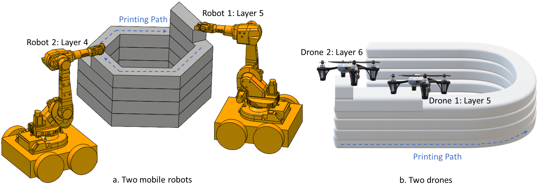
.
Figure 2. Synchronous multi-layer printing with a. two mobile robots and b. two drones
In this work, our overall objective is to understand how cooperative multi head strategies influence both the mechanical performance of printed parts and the risk of early age deformation in large scale structures. For concrete AM, this requires a careful examination of potential collapse risks associated with multi head cooperative print strategies.Existing studies have primarily examined single-head systems [19] , where relationships between rheology [20–22] buildability, toolpath [23–25] and failure modes are now relatively well understood [26,27]. For multi-head systems, however, the toolpath and inter-pass timing are fundamentally altered, which changes the evolving stress state in the fresh material and can induce new failure modes that are not captured by single-head models [28]. At the same time, direct experimental exploration of these strategies, especially at architectural scales, is costly, time consuming, and often impractical [29]. This creates a clear need for modeling tools that can rapidly evaluate multi-head strategies and provide process guidelines without extensive trial-and-error.
The fundamental concept that connects both parts of this study is that failure occurs when the stresses generated during printing exceed the evolving strength of the material, whether tensile strength in PLA or yield stress in fresh concrete. In the polymer experiments, we quantify how SMLP modifies inter and intra layer gap times and measure the resulting tensile and tear strengths for different speeds and spans. For concrete AM, we calculate the maximum shear stress distribution during printing using Murata's slump prediction model [21] and force equilibrium, and we estimate the time dependent yield stress from the elapsed time after deposition. By comparing these stress and yield stress fields for different multi head strategies, we predict the time of collapse of deposited concrete. To highlight the advantages of SMLP, we compare it with traditional decomposition based multi head printing and bi directional single head printing using total build time and predicted collapse time as key performance metrics. A sensitivity analysis on rheological properties and printing parameters for each strategy provides additional insight into structural stability and failure and offers guidance for selecting process parameters in future cooperative AM systems. In summary, this work introduces a decomposition free SMLP strategy, provides systematic experimental evidence from PLA FDM on its effect on mechanical properties, and develops an analytical framework for concrete AM that links multi head toolpaths to early age collapse, together offering a unified basis for designing structurally robust cooperative printing strategies.

Methodology

Experimental procedure for extrusion-based polymer printing

2.1.1 Materials and equipment
The filament used in this study was Bambu PLA Basic, a modified polymer composite consisting of 99% polylactic acid and less than 1% of additives such as Polycaprolactone (PCL), this is a common blend formula, oriented for high-speed printing and can achieve printing speeds up to 250-300 mm/s in certain machines. Being the most common material in FDM printing, PLA is widely adopted as it's easy to print and inexpensive. According to the data provided by the supplier, typical values of material properties are listed in Table 1. Filament spools underwent a dehumidification process in a laboratory oven at 56 °C for a minimum duration of 4 hours. Printing operations were conducted in an ambient environment maintained at 21 °C and 50% relative humidity. Each experimental batch was completed within a 3-hour timeframe.
Table 1. Materials properties of PLA material utilized in this study.
Property | Value
Density | 1.24 g/cm³
Melting temperature | 160 °C
Glass Transition Temperature | 60 °C
Young’s Modulus (X-Y) | 2580 ±220 MPa
Young’s Modulus (Z) | 2060 ±170 MPa
Tensile Strength (X-Y) | 35 ± 4 MPA
Tensile Strength (Z) | 31 ± 3 MPA
All samples were printed on a modified Independent Dual Extruder (IDEX) machine based on Tronxy Gemini S. As shown in Figure 3a, a customized dual-head mount was utilized for SMLP capabilities and it had two separate control boards for each hotends compared to the in-built capability. The FDM machine offers a maximum build volume of 300 x 300 x 390 mm for single-extruder operation and 180 x 300 x 390 mm when utilizing both extruders. With a maximum extrusion temperature of 275°C, it is compatible with a range of thermoplastic filaments. The printer is based on core-xy overall configuration, equipped with an OSG dual-axis metal guide rail on its X-axis and reports a positioning precision of 0.012 mm (XY) and 0.004 mm (Z). Additional integrated features include filament run-out detection and a power-loss print resumption function.
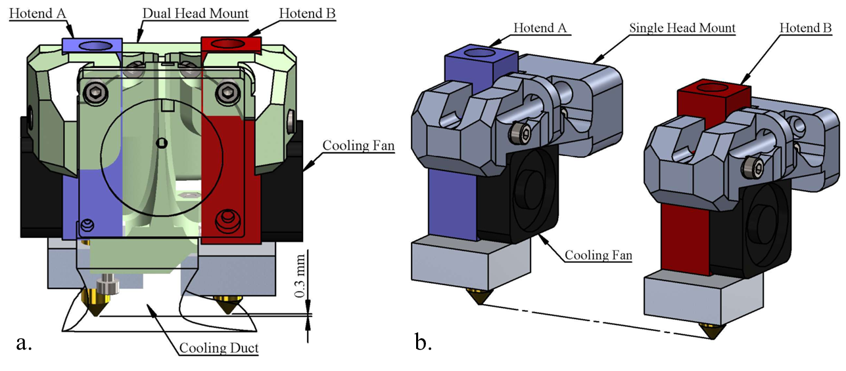
Figure 3. a. Customized dual-head mount for SMLP printing and b. default mount for dual-head printing on the FDM machine.

2.1.2 Specimen and experimental design
Ideally, printed plastic specimens should conform to the ISO 527-1 Tensile Test on Plastics standard. However, the inherent design limitations of the core-xz structure, specifically the shared linear guide rail along the x-axis for both printhead carriages, leads to their synchronized movement along the y-axis. This coupling of printhead travel patterns consequently precluded the controlled deposition of multiple lines along the y-axis. For the experimental testing conducted in this study, ASTM D882-18 (similar to ISO 527-3 but not considered fully equivalent) was adopted. This standard specifies the determination of tensile properties for plastics in the form of thin sheets less than 1.0 mm in thickness, a condition compatible with the capabilities of the experimental setup. The nominal width of the specimens shall be in the range from 5.0 mm to 25.4 mm, and the width to thickness ratio should be greater than 8. And the test specimens should be selected so that thickness is uniform to within 5% of the average thickness over the length of the specimens between the grips. Specimens fabricated for this study maintained a consistent width of 18 mm, corresponding to 60 deposited layers, and a thickness of 0.4 mm. Since, one of the objective was to evaluate the effect of SMLP printing strategy for cooperative printing on the tensile strength and inter-layer adhesion. The independent variables to achieve it where varied as follows: print speed: 5 mm/s to 60 mm/s with 5 mm/s step size and length: 50 mm, 100 mm and 150 mm. The parameters that remained unchanged were layer height: 0.3 mm, gap between two heads: 33 mm, travel speed: 60 mm/s, nozzle temperature: 208°C and bed temperature: 60°C. For each combination of print speed and length, a total of two replicate specimens were fabricated. Additionally, to demonstrate the effectiveness of proposed strategy, it was compared with the state-of-the-art cooperative printing strategy for multiple heads, as illustrated in Figure 4a. Prior to mechanical testing, all specimens underwent visual inspection. Samples with noticeable defects, such as flowrate fluctuations, insufficient inter-layer adhesion, or visible void disconnected regions, were identified and excluded from further analysis. Valid specimen was then utilized for measuring the ultimate tensile strength and tear strength analysis, assessing resistance to force applied along the specimen's width.
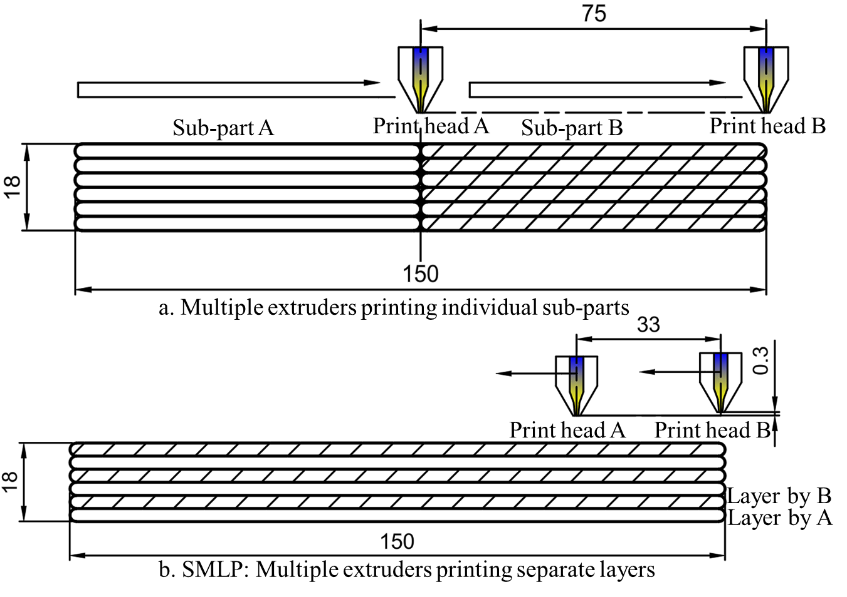
Figure 4. Illustration of two printing strategies for multi-head printing utilized in the experiment (All dimensions are in mm).

2.1.3 Printing procedure
SolidWorks was used for 3D modeling, then Ultimaker Cura 5.11 acted as slicing software, converting STL model to toolpath in Gcode format, then the gcode was handled by a python programme for afterprocessing, where the inter-layer behaviour was modified to more controlled layer change movement and the split the task for two printheads. Slicing was done in Cura with setting profiles modified to comply with the target motion for carriage #1, the path will eventually be duplicated in actual printing process and task distributed between two printheads. The printing machine was loaded with Marlin 1.1 firmware, with configuration files where the duplicate mode was enabled to give synchronized instructions to both printheads with controlled XY offset. Y-axis's acceleration was capped at 500 mm/s² to reduce vibration of the build plate and avoid losing steps during fast travel. It is also noteworthy that in the initialization sequence gcode, which includes heating and homing procedures, the coordinate system for extrusion commands was reconfigured to relative positioning. This adjustment allows better integration of post-processing operations, particularly given that extrusion amounts for each pass are calculated volumetrically, by removing the need to account for accumulated historical lengths simplifies modifications. All specimens were oriented vertically (XZ) on the build plate, with one long edge in contact with the build surface along Y-axis. The specimen thickness was defined by a single extruded line of 0.4 mm. Printing was performed on a smooth glass build plate covered with paper-based masking tape, without the use of printed supplementary adhesion structures such as brim or raft. To ensure firm attachment and prevent warping, the printhead was calibrated to a first-layer height of 0.2 mm, thereby increasing the contact area with the masking tape.

2.1.4 Testing procedure
Mechanical testing was performed following the ASTM D882-18 "Standard Test Method for Tensile Properties of Thin Plastic Sheeting," selected as the appropriate standard for specimens with a thickness less than 1.0 mm. Tensile testing was performed using a TSA750 test stand with a M5-750 digital force gauge and G1061-2 wedge grips, the combination provides capacity upto 3750 N (750 lbF / 375 kgF), Accuracy of the force gauge is ±0.1% of full scale, and resolution is 1/5000. Live data stream was captured on a PC connected through RS232 interface which transmits at 500 Hz output rate. Specimens were mounted in the grips with the longitudinal axis aligned with the direction of applied force. The initial grip separation (gauge length) was set to match the designated test region length for each experimental condition. Constant incremental force was applied gradually until specimen rupture. The crosshead speed was selected to provide a consistent strain rate according to the guidelines. Prior to testing, specimen dimensions were verified using vernier calipers with an accuracy of ±0.02 mm. The width and thickness were measured at five distinct points along the gauge length to determine the average cross-sectional area ($A_{0})$. The ultimate tensile strength ($σ_{t}$) was calculated by dividing the maximum force ($F_{max}$) recorded during the test by the original average cross-sectional area, as shown:
 | $$σ_{t}=\frac{F_{max}}{A_{0}}$$ | (1)
The result is expressed in MPa. Specimens exhibiting obvious manufacturing defects or failures at the grip interface (jaw breaks) were excluded from the dataset. The second replicate from each experimental condition was subjected to tear resistance analysis. The specimen was oriented to apply load perpendicular to the deposited layers to assess the resistance to force applied along the specimen's width. The maximum force required to initiate and propagate separation was recorded as the tear strength.

Analytical modeling for extrusion-based concrete printing
The printing path is one of the critical input parameters that typically must to be determined before printing, including specifying the start and end coordinates as well as the trajectory and motion planning. There are numerous path planning strategies that may be adopted even for a single-head additive manufacturing scenario of a simple thin wall, such as bi-directional versus single-directional. The choice of strategy is significant because the starting point for printing each layer can impact both the printing time and the yield stress of the printed concrete (and similarly the thermal stress in metal-based AM) [30,31]. Additionally, different printing paths result in different total build times and inter-layer gap times. As printing times change, the yield stress distribution changes as well. This consideration becomes even more important with multiple heads, as a larger number of interconnected printing strategies become available. Traditionally, the part is decomposed into 𝑛 sub-parts, which are then assigned to 𝑛 printing heads [2,10]. For example, as illustrated in Figure 3b, two robots collaborate to print a wall by dividing it into two sections, with each section managed by a separate print head. Alternatively, the SMLP approach proposed in this study assigns each layer of the part to a different head for printing. The hypothesis is that this method will combine the time efficiency of traditional multi-head printing with the uniform structural integrity achieved by using a single head. The different printing strategies employed in analytical work, including the proposed synchronous multi-layer printing, are depicted in Figure 3.
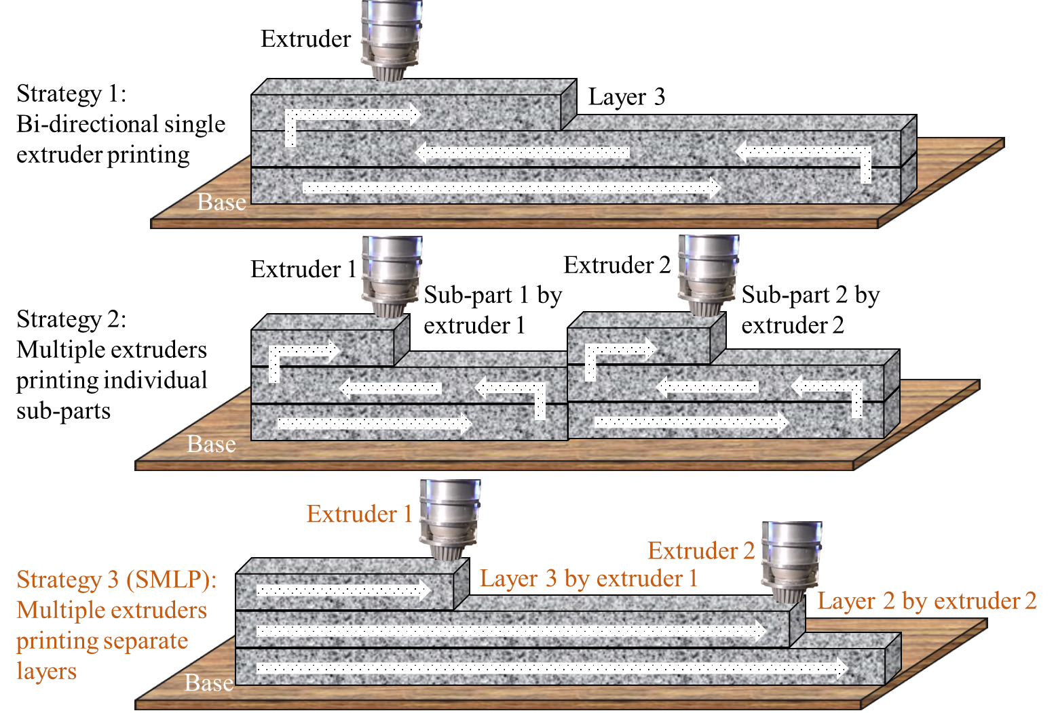
Figure 5. Simple illustration of different single-head and multi-head strategies adopted in this work

2.2.1 Assumptions for the analytical model
In this work, the structural integrity of printed structures fabricated using the single-head and multi-head strategies (state-of-the-art versus the proposed approach) are evaluated through stress analysis associated with extrusion-based additive manufacturing of concrete material for a straight wall. In this process, it is widely known that the elapsed time from the deposition of fresh concrete to a fully printed structure affects the stress distribution within the part, and thus, adequate yield stress of fresh concrete to print is necessary to avoid any deformation or collapse during the printing process. Consequently, analytical models are established for the newly presented cooperative printing strategy to detect early failure, and are then compared with the existing results associated with single-head and stata-of-the-art decomposition-based cooperative printing strategies. Figure 6 shows the flow chart illustrating the analytical framework utilized in this study. With design requirements and printing strategies considered as inputs, the analytical model iteratively evaluates each layer and discrete points throughout the layer, starting from layer 1, to determine if the yield stress of the printed concrete is higher than the maximum shear stress, ensuring a stable printing process. If maximum shear stress exceeds the yield stress in the initial layers, the model indicates early deformation and predicts the time of collapse. Important metrics such as deformation and build time for all strategies are obtained from the analytical model. Based on these metrics, an optimal strategy can be decided for cooperative 3D printing. Several assumptions were made to simplify the calculations:
- The interlayer bond strength reduces as the printing time gap between layers increases. However, Chen et al. [32] demonstrated that, in large-scale printing with single head, short time intervals (<10 minutes) had minimal to no effect on the bonding properties based on experimental and numerical studies. Moreover, for parts of the same size, multi-head strategies typically entail shorter printing gap times between layers compared to single-head printing. As a result, since the time gap between layers in this study is less than 10 minutes, the impact of printing gap times on the bonding can be neglected, and thus, only stress-driven phenomena and their effect on structural integrity are considered.
- The supply of raw materials is assumed to be continuous and ideal.
- Fresh concrete is deposited vertically, with the width, height (i.e., thickness), and length of each layer remaining constant throughout the study. A multi-layer, single-track structure is adopted.
- The extrusion head is assumed to deposit perfectly rectangular cross-section beads.
- The speed of multiple extrusion heads are assumed to be similar and constant throughout this study.
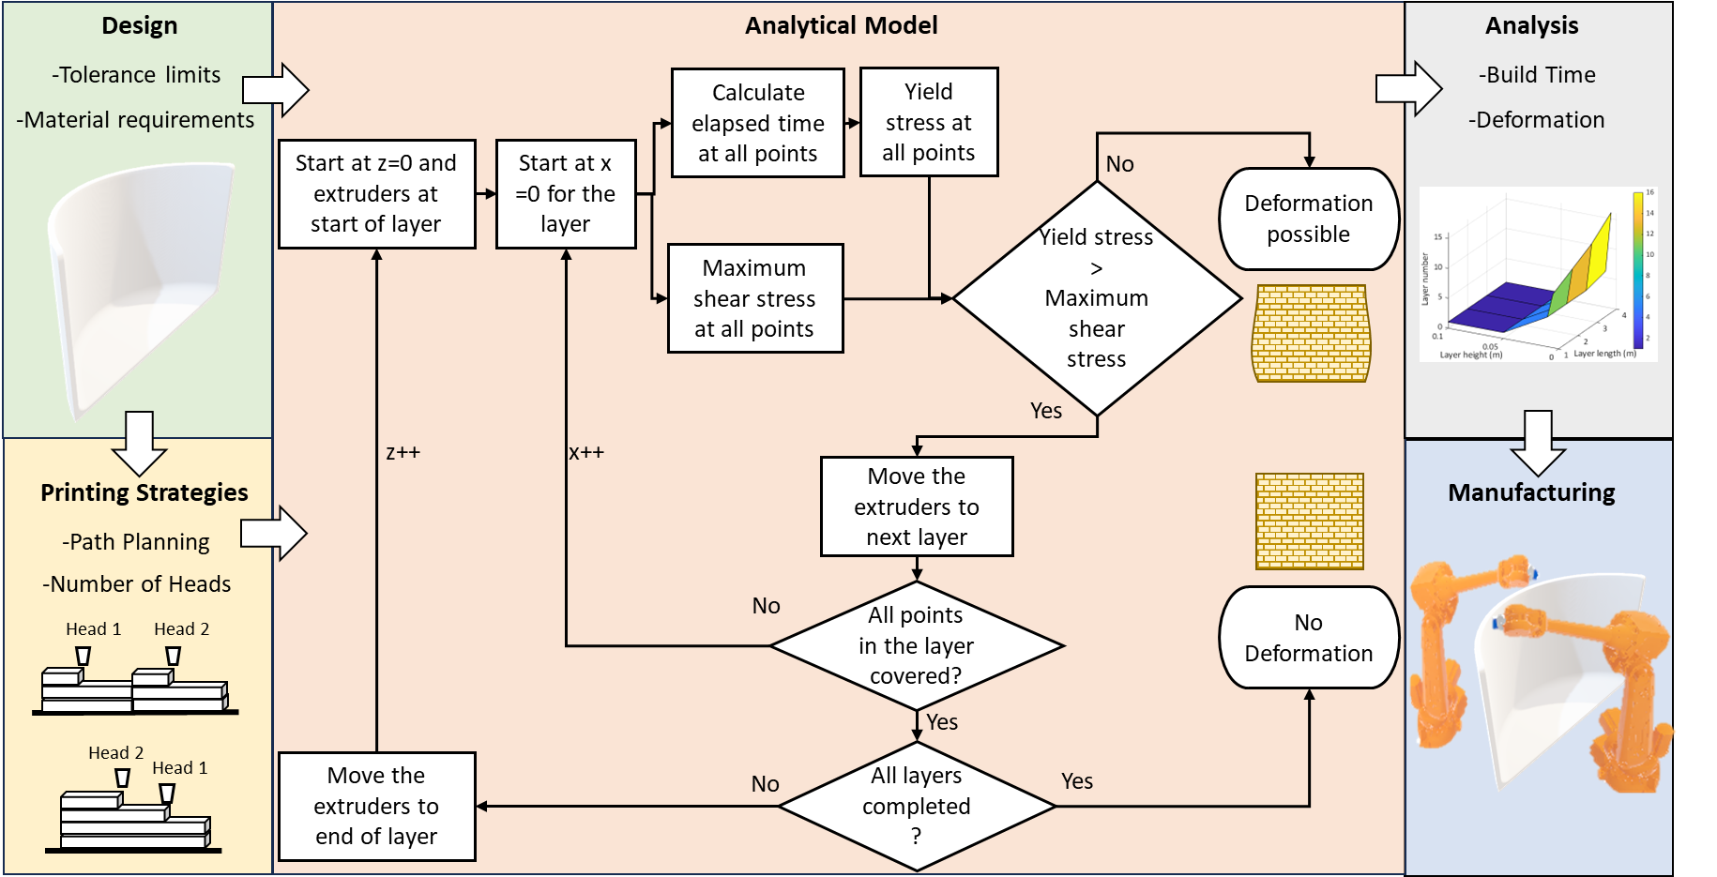
Figure 6. Analytical framework for modeling structural integrity in cooperative AM

2.2.2 Yield stress distribution
Studies in the literature have demonstrated that the yield stress of fresh concrete varies with elapsed time ($t_{p})$ in either linear or exponential manner [27]. This relationship can be expressed as follows:
 | $$τ_{x}\left(t_{p}\right)=τ_{0}e^{αt_{p}}$$ | (2)
 | $$τ_{x}\left(t_{p}\right)= αt_{p}+τ_{0}$$ | (3)
where $α$ and $τ_{0}$ are the hardening coefficient and the initial yield stress. Equation 2 or 3 can be selected and applied based on the yield stress measurement results of the fresh concrete. However, to ensure safety, It is always assumed that the yield stress calculated from the elapsed time-yield stress equation is lower than the measured yield stress.

2.2.2.1 Single-head printing using strategy 1
In strategy 1, at any point where fresh concrete has been extruded at time ($t_{0}$), and with the current position of the extruder ($t_{e})$, the yield stress can be calculated by substituting Eq. 1 into Eq. 4, 5, as follows:
 | $$τ_{1x}\left(L_{e},L_{o}\right)=τ_{0}e^{α*\left(\left(\frac{h}{V_{t}}\right)\left({\left[\frac{L_{e}}{l}\right]}_{f}-{\left[\frac{L_{o}}{l}\right]}_{f}\right)+\frac{L_{e}-L_{o}}{V_{p}}\right)}$$ | (4)
 | $τ_{1x}\left({L_{e},L}_{o}\right)= α\left(\left(\frac{h}{V_{t}}\right)\left({\left[\frac{L_{e}}{l}\right]}_{f}-{\left[\frac{L_{o}}{l}\right]}_{f}\right)+\frac{L_{e}-L_{o}}{V_{p}}\right)+τ_{0}$ | (5)
where $L_{e}$ and $L_{o}$ are the respectively lengths measured from extruder position at any point (o) from start point, as illustrated in Figure 7a. In the above equations, the yield stress is expressed as a function of lengths. However, it is preferable to represent yield stress as a function of the spatial coordinates $\left(x,z\right)$. This is because the coordinates provide a clearer understanding of the locations of potential failures. Therefore, the following relationship can be established:
 | $L_{o}\left(x,z\right)=\left\{\begin{aligned}x+l{\left[\frac{z}{h}\right]}_{f} ,where{\left[\frac{z}{h}\right]}_{f}is odd \\ \left(l-x\right)+l({\left[\frac{z}{h}\right]}_{f}-1) ,where{\left[\frac{z}{h}\right]}_{f}is even\end{aligned}\right.$ | (6)
 | $L_{e}\left(x^{'},z^{'}\right)= \left\{\begin{aligned}x^{'}+l{\left[\frac{z^{'}}{h}\right]}_{f} ,where{\left[\frac{z^{'}}{h}\right]}_{f}is odd \\ \left(l-x^{'}\right)+l{(\left[\frac{z^{'}}{h}\right]}_{f}-1) ,where{\left[\frac{z^{'}}{h}\right]}_{f}is even\end{aligned}\right.$ | (7)
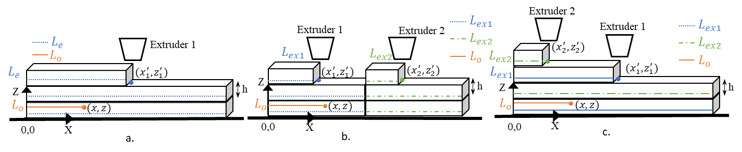
Figure 7. Different print lengths based on current extruder position for a. strategy 1, b. strategy 2, and c. SMLP

2.2.2.2 Cooperative multi-head printing using strategy 2
For strategy 2, at any point where fresh concrete has been extruded at time ($t_{0})$, and with the current position of the extruders to be similar to that in strategy 1, and given that the elapsed time for the material extruded by both the extruders is consistent, the shear stress can be calculated as follows:
 | $$τ_{2x}\left(L_{o},L_{e}\right)=τ_{0}e^{α*\left(\left(\frac{h}{V_{t}}\right)\left({\left[\frac{{2L}_{e}}{l}\right]}_{f}-{\left[\frac{{2L}_{o}}{l}\right]}_{f}\right)+\frac{L_{e}-L_{o}}{V_{p}}\right)}$$ | (8)
 | $τ_{2x}\left({L_{o},L}_{e}\right)= α\left(\left(\frac{h}{V_{t}}\right)\left({\left[\frac{2L_{e}}{l}\right]}_{f}-{\left[\frac{{2L}_{o}}{l}\right]}_{f}\right)+\frac{L_{e}-L_{o}}{V_{p}}\right)+τ_{0}$ | (9)
However, as a function of coordinates, the location of the extruders plays a crucial role in establishing the relationship between shear stress distribution across the entire built wall. The extruders operate in independent regions without overlaps. To determine which extruder was used to deposit material at any point $\left(o\right)$, one can simply check if its $x$ coordinate is between 0 and $l$/2 or between $l$/2 and $l$ as shown in Figure 8.
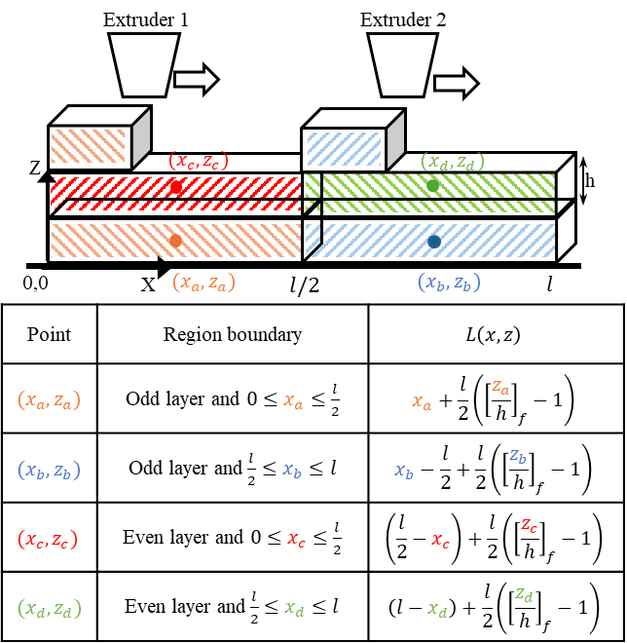
Figure 8. Relationship between various points in the printing path to the print length in strategy 2

2.2.2.3 Cooperative multi-head printing using strategy 3 (SMLP)
For SMLP, at any point where fresh concrete has been extruded at time ($t_{0})$, and with the current position of the extruder, the yield stress can be calculated, as shown:
 | $$τ_{3x}\left(L_{o},L_{ex1},L_{ex2}\right)=\left\{\begin{aligned}τ_{0}e^{α*\left(\left(\frac{D}{V_{max}}\right)\left({\left[\frac{L_{ex1}}{l}\right]}_{f}-{\left[\frac{L_{o}}{l}\right]}_{f}\right)+\frac{L_{ex1}-L_{o}}{V_{p}}\right)} , where {\left[\frac{L_{o}}{l}\right]}_{c} is odd \\ τ_{0}e^{α*\left(\left(\frac{D}{V_{max}}\right)\left({\left[\frac{L_{ex2}}{l}\right]}_{f}-{\left[\frac{L_{o}}{l}\right]}_{f}\right)+\frac{L_{ex2}-L_{o}}{V_{p}}\right)} , where {\left[\frac{L_{o}}{l}\right]}_{c} is even\end{aligned}\right.$$ | (10)
where $L_{ex1}$ and $L_{ex2}$ are the lengths measured for extruder positions and $L_{o}$ is the length measured for any point $\left(o\right)$ from start point of the extruder used for deposition as shown in Figure 7c. The time delay does not affect the elapsed time because, depending where the layer point (o) exists, it is compared with the respective extruder’s position. For instance, if point $\left(o\right)$ is in an odd layer, the elapsed time is calculated with extruder one’s position. The yield stress as a function of the coordinates of point $\left(x,z\right)$ in the space can be established as:
 | $L_{o}\left(x,z\right)=\left\{\begin{aligned}x+l\left(\frac{{\left[\frac{z}{h}\right]}_{c}-1}{2}\right) ,where{\left[\frac{z}{h}\right]}_{c}is odd \\ x+l\left(\frac{{\left[\frac{z}{h}\right]}_{c}}{2}-1\right) ,where{\left[\frac{z}{h}\right]}_{c}is even\end{aligned}\right.$ | (11)
 | $L_{ex1}\left(x_{1}^{'},z_{1}^{'}\right)=x_{1}^{'}+l\left(\frac{{\left[\frac{z_{1}^{'}}{h}\right]}_{c}-1}{2}\right); L_{ex2}\left(x_{2}^{'},z_{2}^{'}\right)=x_{2}^{'}+l\left(\frac{{\left[\frac{z_{2}^{'}}{h}\right]}_{c}}{2}-1\right)$ | (12)
Where ${\left[.\right]}_{c}$ is the ceiling function and ($x_{1}^{'},z_{1}^{'}$) and ($x_{2}^{'},z_{2}^{'}$) are the extruder positions for extruder 1 and 2, respectively.

2.2.3 Maximum shear stress distribution
The relationship between material properties or rheological properties of concrete and stress is well established. The pressure exerted by the weight of concrete above a layer results in a compressive normal stress on that layer. This compressive normal stress due to height $z$ of material printed on the $n^{th}$ layer in an x-z plane can be shown as:
 | $$σ\left(z\right)=ρg\left(nh-z\right)$$ | (13)
where $ρ$ is the density of fresh concrete and g is the gravity acceleration. The maximum shear stress which acts on the surface is approximated by one half of the pressure and can be expressed as:
 | $$τ_{\max\left(z\right)}=0.5ρg\left(nh-z\right)$$ | (14)
The maximum shear stress distribution for a fully formed part with the same number of layers will be consistent across different strategies. However, when fresh concrete is only partially formed within the same layer, the maximum shear stress distribution will vary depending on the strategy employed.

2.3.2.1 Single-head printing using strategy 1
For strategy 1, the normal compressive stress and the maximum shear stress generated at a position $\left(x^{'},z^{'}\right)$ within a build-up layer in the x-y plane can be calculated as shown in Figure 9, where $τ_{d}$ is the shear stress caused by the discharge pressure. It is an additional stress acting at the point where the printing is taking place. There are three primary regions, i.e., before, at and after the head, that have the change in normal compressive and maximum shear stress of the deposited concrete.
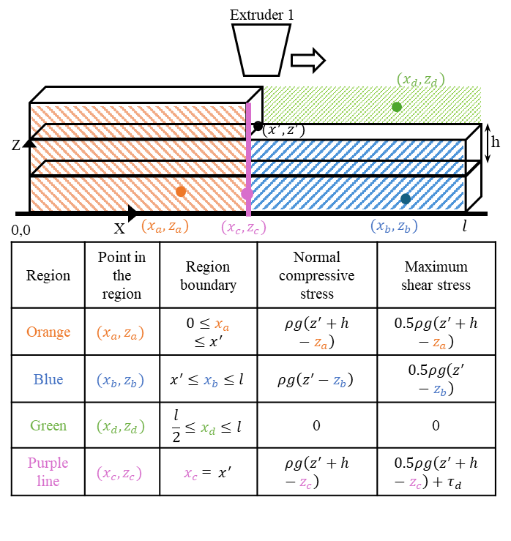
Figure 9. Normal compressive and maximum shear stress while printing using strategy 1

2.2.3.2 Cooperative multi-head printing using strategy 2
For strategy 2, with two extruders located at ($x_{1}^{'},z_{1}^{'}$) and ($x_{2}^{'},z_{2}^{'}$), where $z_{1}^{'}$ and $z_{2}^{'}$ are equal as both are printing the same layer. Additionally, extruder head 2 will be $l$/2 units away in the x-direction from extruder head 1. The normal compressive stress generated from these positions of a build-up layer in the x-y plane is shown in Figure 10 with consideration of various scenarios. The scenarios are critical as the printing direction is changed across layers, which impacts the deformation or failure point of the structure. Moreover, the maximum shear stress generated from these positions of a build-up layer in the x-y plane as illustrated in Figure 8.
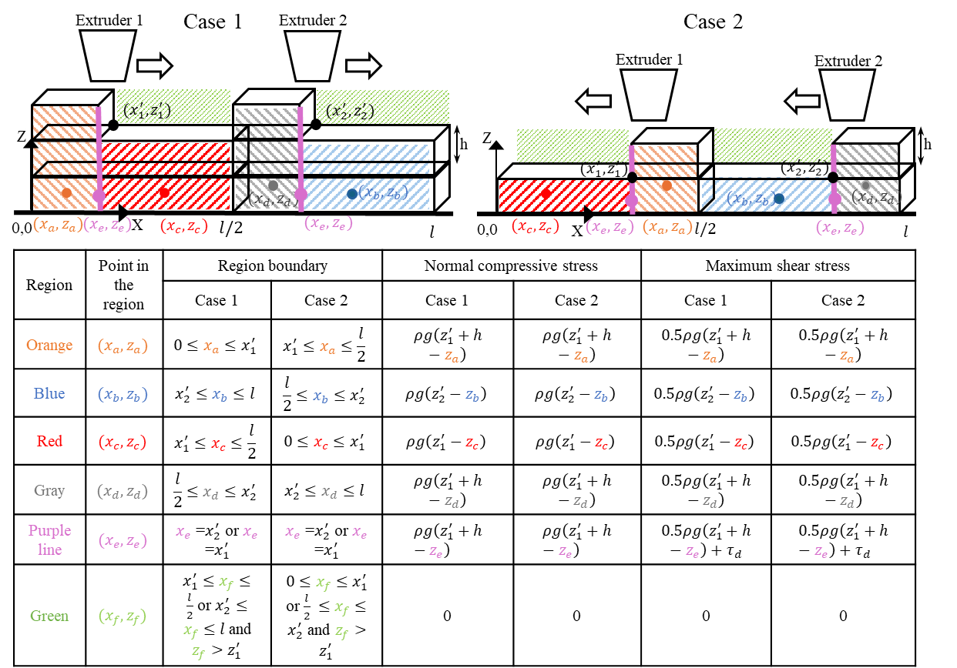
Figure 10. Normal compressive and maximum shear stress while printing using strategy 2

2.2.3.3 Cooperative multi-head printing using strategy 3 (SMLP)
In Figure 11, $τ_{d1}$and $τ_{d2}$ represent the shear stresses caused by the discharge pressures of extruder 1 and extruder 2. It is important to note that $z_{1}^{'}$ is consistently used in the tables as both $z^{'}$s, (i.e., $z_{1}^{'}$, $z_{2}^{'}$) are the same for uniform layer heights. However, in SMLP, there are two extruders operating at different $z$-positions ($x_{1}^{'},z_{1}^{'}$) and ($x_{2}^{'},z_{2}^{'}$), as illustrated in Figure 7c. Therefore, from a positional perspective, two configurations are possible: either extruder 1 is ahead of extruder 2, or vice versa. The relative position of the extruders impacts the failure point of the wall. Additionally, this relative position is influenced by several factors, including speed of extruders, the time delay between the operations of extruders, and the number of layers to be printed. The normal compressive stress and maximum shear stress generated at specific positions within a build-up layer in the x-y plane for SMLP can be calculated as illustrated in Figure 11, where $τ_{d1}$and $τ_{d2}$ are the shear stress caused by discharge pressures of extruder 1 and extruder 2.
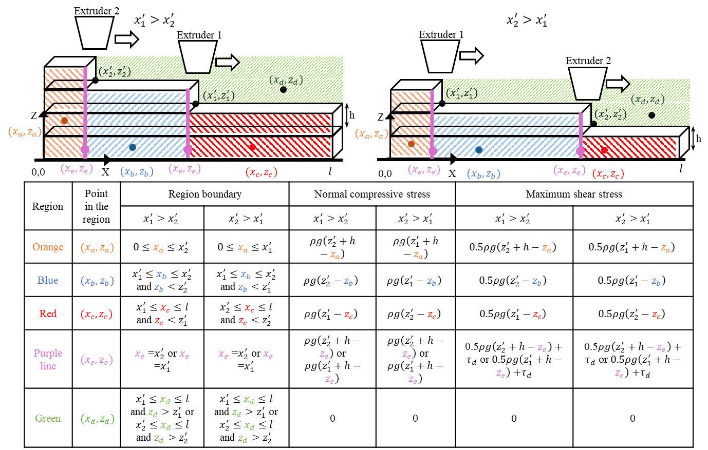
Figure 11. Normal compressive and maximum shear stress while printing using SMLP strategy

3. Results

3.1 Experimental results for extrusion-based polymer printing

3.1.1 Analysis for tensile strength
The material was initially tested along the vertical height of thin wall. A two-way ANOVA (no interaction term reported) indicates both factors significantly affect tensile strength: print speed, F(11,22)=2.52, p=0.031; print length, F(2,22)=4.58, p=0.022 as shown in Table 2. Model fit is moderate (R²=62.6%, R²_adj=40.6%) with residual standard deviation S=1.29. From sums of squares, the effect size is larger for speed than for span: partial η²_speed = 46.17/(46.17+36.61) ≈ 0.56 vs partial η²_length = 15.23/(15.23+36.61) ≈ 0.29. The probability test on the data showed normality (Anderson–Darling test, AD = 0.384, p = 0.377) and all the assumptions of ANOVA were met and can be seen in the Figure 12. Practically, this says (i) where you set the speed matters more for tensile performance than which of the tested spans you print, and (ii) once speed is controlled, span still contributes a non-trivial (≈30%) share of explainable variance. These findings align with the data trends: a mid-speed band yielded the best strengths, and longer spans (larger inter-pass gaps) tended to depress strengths relative to shorter spans.All the assumptions of ANOVA were passed and in fact
Table 2. Two-way ANOVA results for tensile strength
Source | DF | SS | MS | F | P
Print speed | 11 | 46.16 | 4.20 | 2.52 | 0.031
Print Length | 2 | 15.23 | 7.62 | 4.58 | 0.022
Error | 22 | 36.61 | 1.66
Total | 35 | 98.01
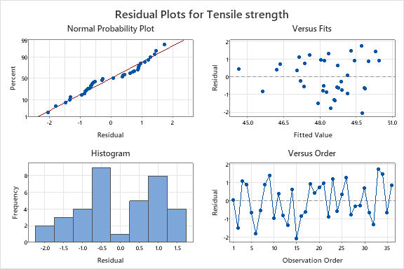
Figure 12 Residual plots for validating assumptions for ANOVA testing for tensile strength
Across 5–60 mm/s, the data still show the expected non-monotonic, gap-time–controlled response, but SMLP is higher than Bi-directional at every speed as seen in Figure 13b. SMLP exhibits a broad high-strength plateau with a local maximum of 355.5 N at 15 mm/s and consistently strong values of ≈341–350 N from 40–60 mm/s, indicating both robustness to speed and headroom to push throughput. In contrast, Bi-directional printing is uniformly lower in absolute terms, peaking at 30 mm/s and staying within ~6% of that around 35–40 mm/s. Span effects match the gap-time mechanism: 150 mm mirrors the SMLP curve (max at 15–20 mm/s); 100 mm favors mid-range speeds ; 50 mm attains the highest values but with greater variability (peak at 15 mm/s, secondary maximum at 50–55 mm/s). Practically, when one policy must cover mixed geometries, a global window of ~25–35 mm/s balances strength and takt; if size-adapting, 15–20 mm/s (150 mm), 25–35 mm/s (100 mm), and 15–25 or 50–55 mm/s (50 mm) are preferred. Most importantly, SMLP delivers superior interlayer tensile strength across the speed while still supporting the documented ≈24% build-time reduction, consistent with its mechanism of more uniform in-layer age and a higher time-evolving yield-stress margin against overburden shear.
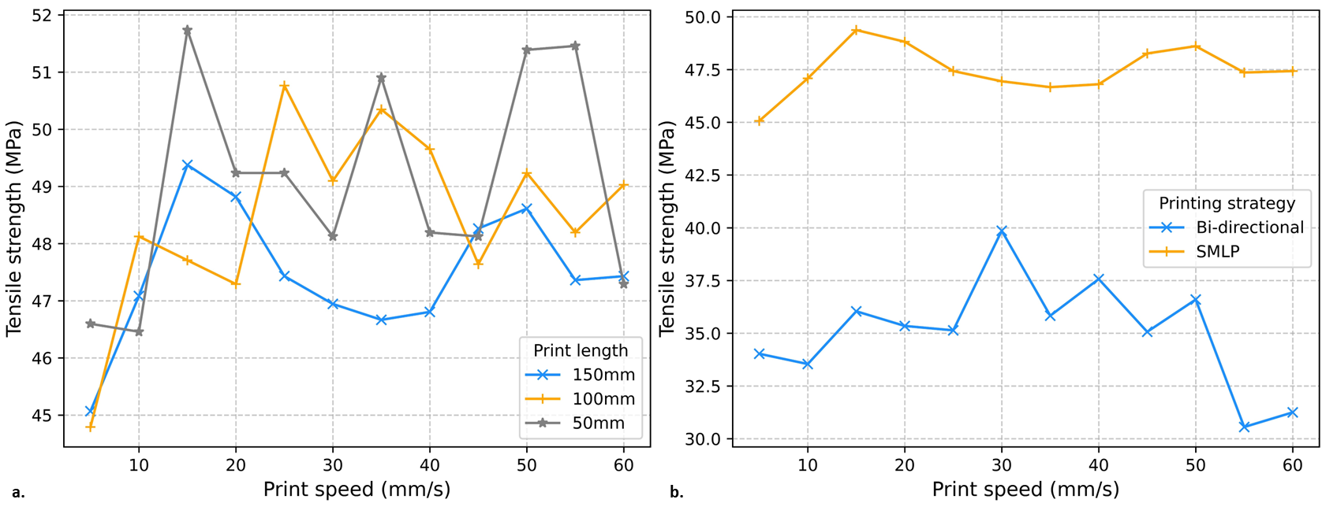
Figure 13. Tensile strength versus print speed for PLA walls: (a) SMLP at three print lengths and (b) comparison of bi-directional and SMLP printing strategies.

3.1.2 Analysis for tear strength
Later, the thin wall tested along it’s horizontal length. For tear strength, both main effects are again significant and stronger than for tensile: print speed, print length as dispalayed in Table 3. Model fit is higher (R²=74.7%, R²_adj=59.7%) with residual S=1.88. Effect sizes from sums of squares show speed dominates: partial η²_speed = 188.355/(188.355+77.476) ≈ 0.71 (large), while partial η²_length = 40.270/(40.270+77.476) ≈ 0.34 (moderate). Engineering interpretation: tear resistance is even more speed-sensitive than tensile strength, reinforcing the gap-time mechanism—very slow speeds over-age the interface; very fast speeds curtail wetting/compaction—while span length still exerts a meaningful second-order influence through its control of inter-pass delay. The 30–40 mm/s band emerges as a robust window that gives near-max tear strength across spans, with 100 mm showing the most consistent performance and 150 mm showing higher variability near 45–50 mm/s. The tear strength was approximately normally distributed as per the normality test (Anderson–Darling test, AD = 0.377, p = 0.392) and Figure 14 shows that all the assumptions for ANOVA were satisfied.
Table 3. Two-way ANOVA results for tear strength
Source | DF | SS | MS | F | P
Print speed | 11 | 188.35 | 17.12 | 4.86 | 0.0001
Print Length | 2 | 40.270 | 20.14 | 5.72 | 0.0010
Error | 22 | 77.476 | 3.52
Total | 35 | 306.10

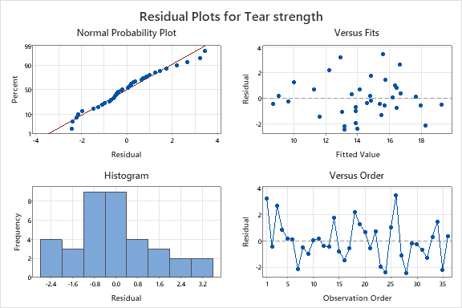
Figure 14.Residual plots for validating assumptions for ANOVA testing for tear strength
Tear strength exhibited the same non-monotonic dependence on print speed seen in tensile tests as seen in Figure 15, reinforcing an inter-pass gap-time mechanism: values rose from low speeds to a mid–high-speed 30–45 mm/s band and then oscillated. Among spans, the 100 mm geometry delivered the highest and most stable performance, reaching ≈135–140 near 35–40 mm/s with only mild decline at higher speeds; 150 mm showed larger variability with a local maximum near ≈45 mm/s and a dip around 50 mm/s, consistent with longer path lengths amplifying turn-induced timing and aging effects; 50 mm was less sensitive overall, with modest peaks near ≈20 and ≈35 mm/s and a secondary rise toward 55–60 mm s⁻¹. Comparing strategies, SMLP matched or exceeded Bi-directional tear strength at nearly all speeds, with its advantage most pronounced in the 30–40 mm/s region—precisely where the method also supports shorter build times. Taken with the tensile results, these data identify 30–40 mm/s as a robust global operating window for SMLP that preserves interlayer integrity while enabling the documented throughput gains, and they rationalize geometry-specific tuning (150 mm → 35–45 mm/s, 100 mm → 30–40 mm/s, 50 mm → 20–35 mm/s) when maximum tear resistance is prioritized.
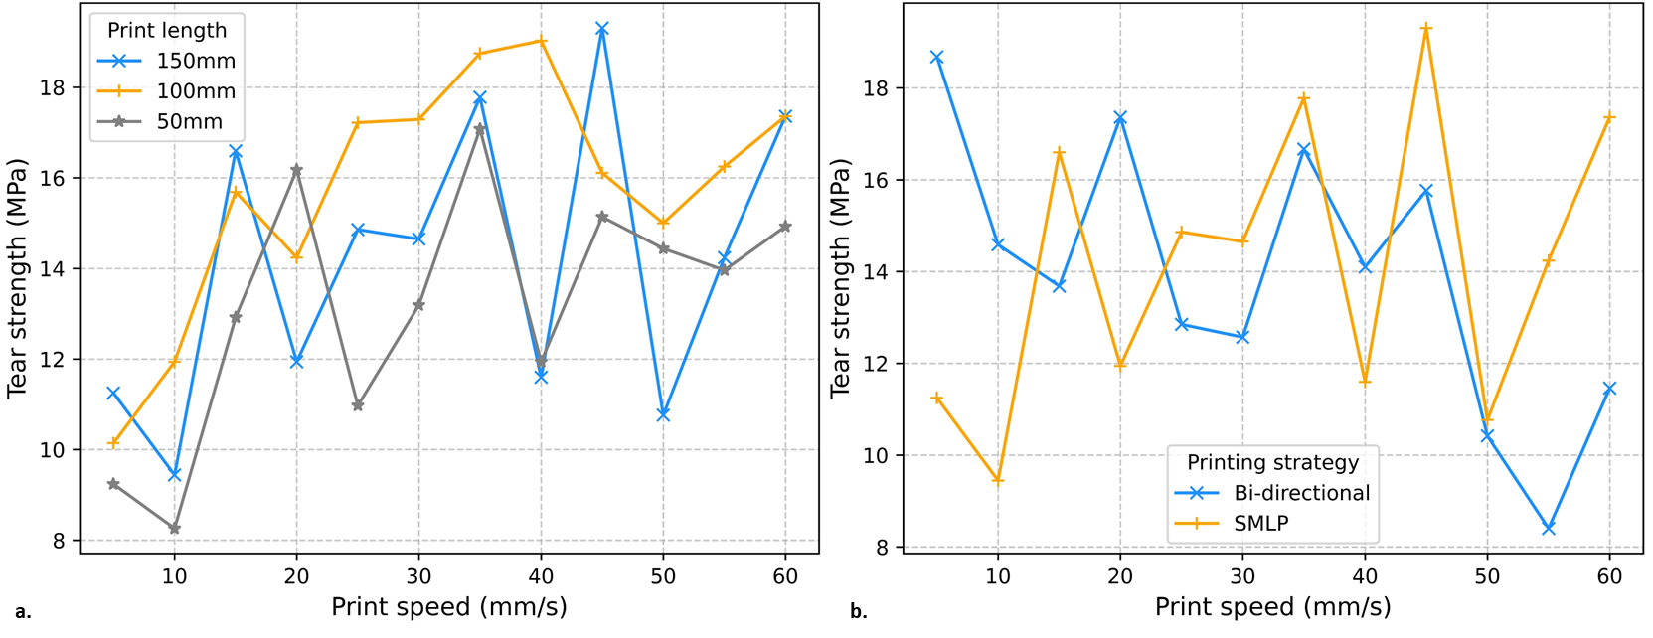
Figure 15.Tear strength versus print speed for PLA walls: (a) SMLP at three print lengths and (b) comparison of bi-directional and SMLP printing strategies.

3.1.3 Comparative results from experiments
A separate two-sample tests show SMLP ≫ Bi-directional for tensile strength (mean gap ≈ +12.4 in SMLP’s favor, 95% CI [10.7, 14.1], p<0.001) but no meaningful difference in tear strength (mean gap −0.27, 95% CI [−2.88, 2.34], p=0.831), as shown in Table 4 and Table 5, respectively. Together with the ANOVAs, the picture is consistent: (i) choose speed first, because it is the largest lever for both tensile and tear; (ii) use SMLP within the mid-speed window, because it preserves or improves tear strength and substantially elevates tensile strength while enabling faster builds; and (iii) account for span as a secondary lever via its impact on inter-pass gap time.
Table 4. Paired t-test and Confidence Interval for tensile strength of thin wall via Bi-direction and SMLP
Source | N | Mean | Stdeviation | SE mean
Bi-directional | 12 | 35.07 | 2.55 | 0.74
SMLP | 12 | 47.49 | 1.16 | 0.33
Table 5.Paired t-test and Confidence Interval for tear strength of thin wall via Bi-direction and SMLP
Source | DF | SS | MS | F
Bi-directional | 12 | 13.88 | 2.98 | 0.86
SMLP | 12 | 14.15 | 3.17 | 0.91
Another point of discussion is initiation and the propagation of cracks for both the printing strategies. As the scope of this study is to introduce the novel printing strategy and investigate it’s strength compared to traditional strategy, we briefly discuss about the failure of specimens and the initiation of the crack. As clearly seen in Figure 16, for the traditional multi-robot printing strategy, the tensile test failure occurs at the decomposition boundary whereas for the SMLP there is no such obvious weak spot but would need further investigations.
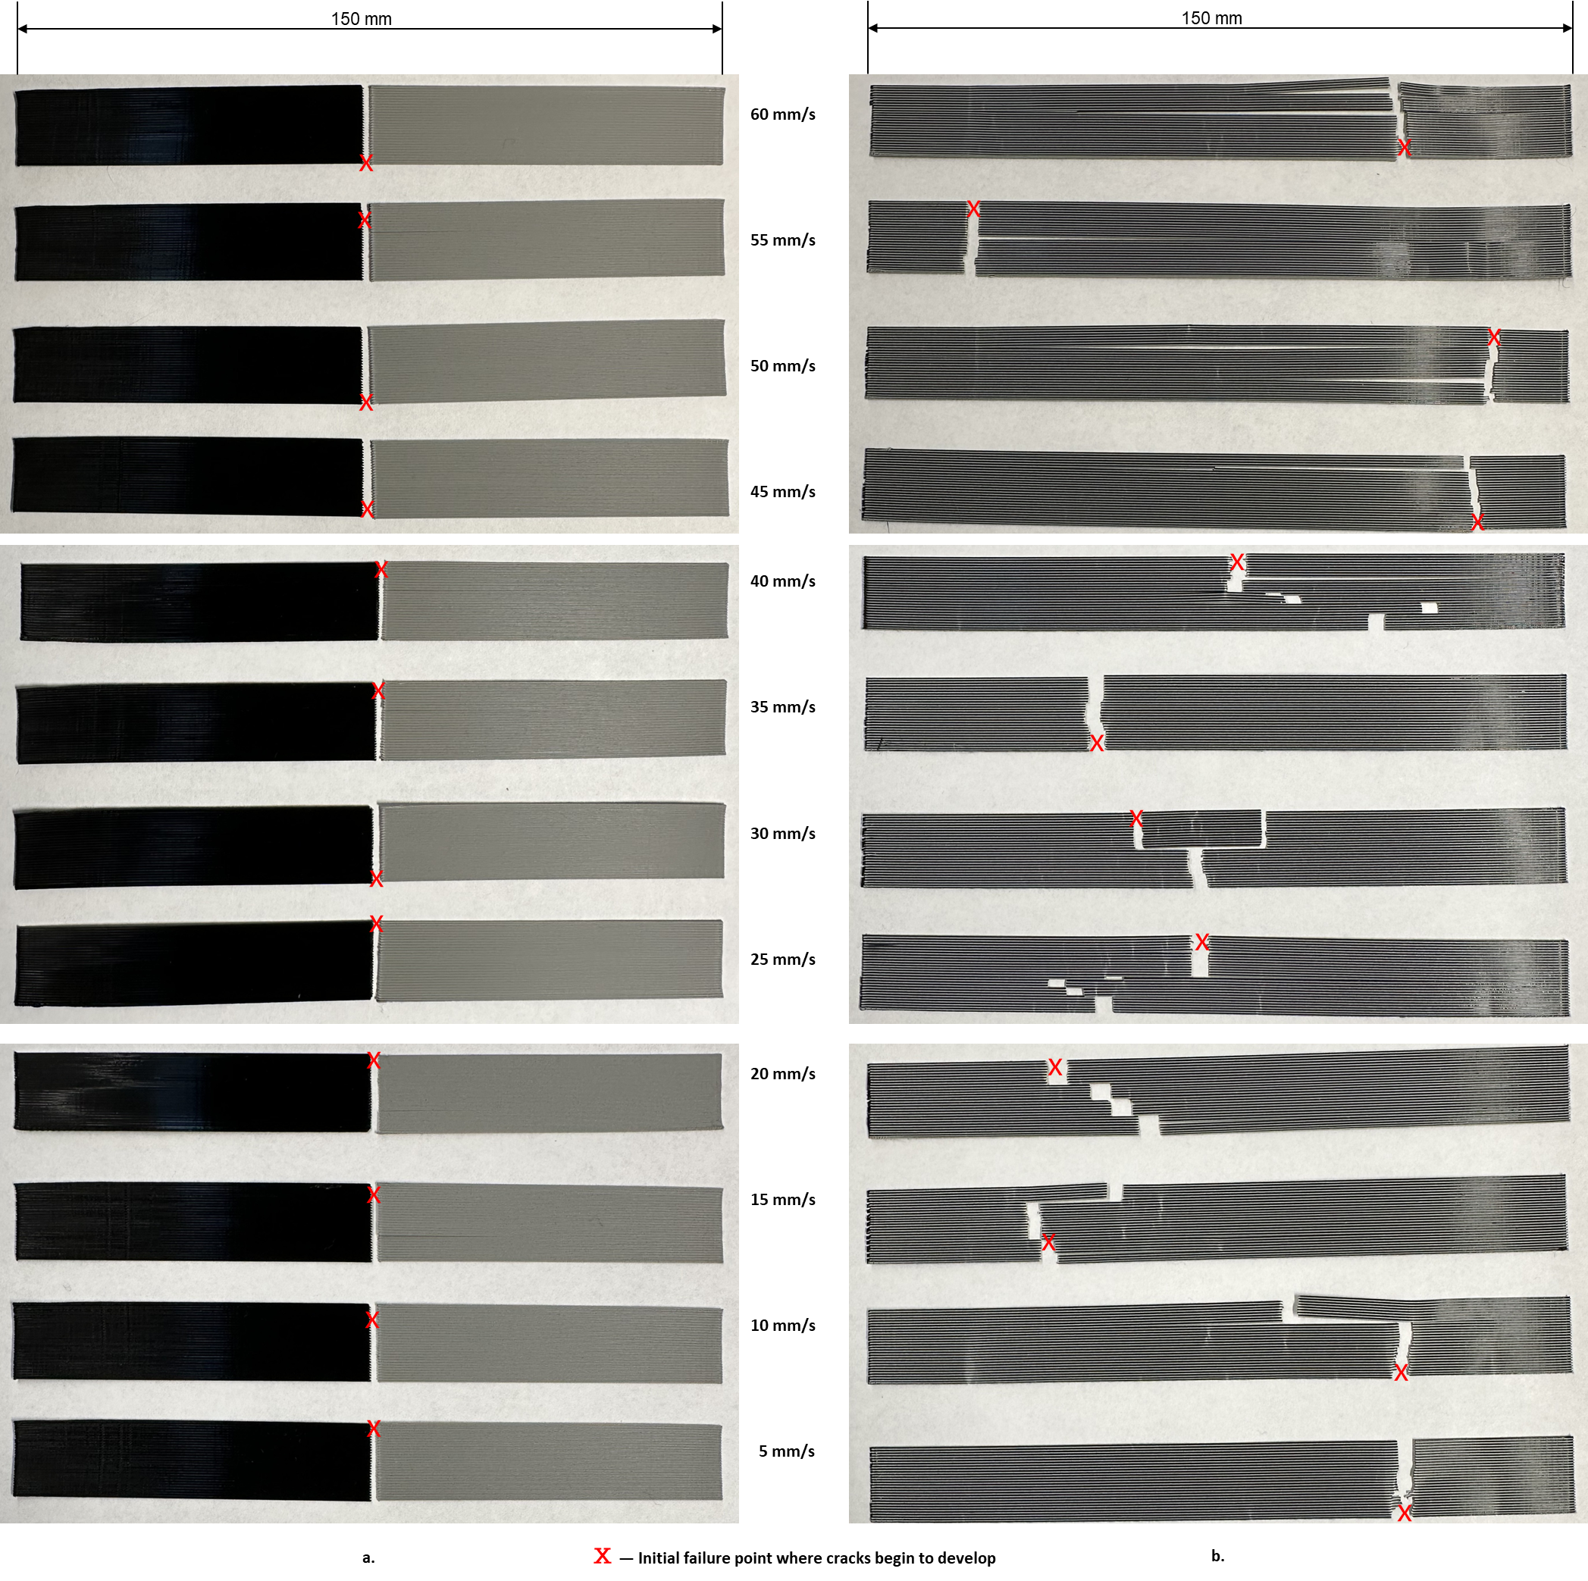
Figure 16. The tensile test specimens printed from a. traditional bi-directional and b.SMLP printing strategies after performing the tests for different print speeds

3.2 Simulation results for extrusion-based concrete printing

3.2.1 Analysis for synchronous multi-layer printing
For checking the hypothesis that SMLP strategy enhances the printing efficiency from single-head strategy as well as improve the structural integrity over traditional multi-head strategy (i.e., strategy 2), first a comparison of build time with strategy 1 and later number of layers built before collapsing with strategy 2 is performed. As demonstrated in Figure 17, SMLP strategy built more layers than strategy 2 (as more as 60 layers) and saves significant amount of time in comparison to strategy 1. The improvement in building layers by SMLP was 100-300% over strategy 2 and the time savings by SMLP was around 24% over strategy 1.
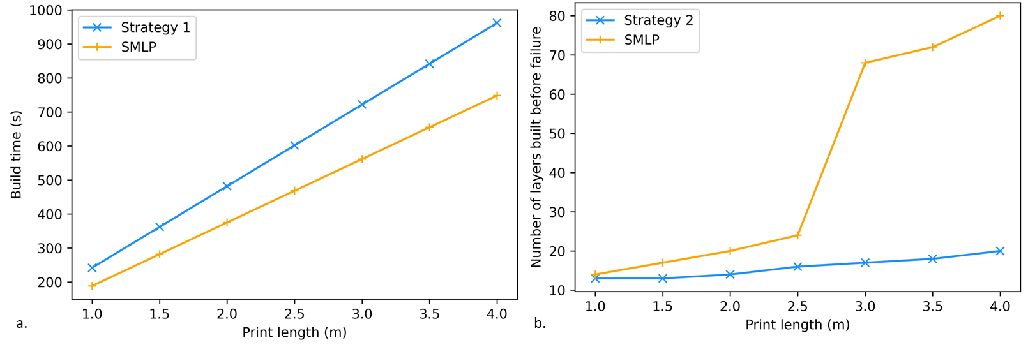
Figure 17. Performance of SMLP compared to a. strategy 1 in build times and b. strategy 2 in number of layers built
The influence of various rheological properties and printing parameters on the structural integrity of concrete deposited through the SMLP strategy was analyzed using analysis of variance (ANOVA). The factors examined were initial yield stress (A: low - 500 Pa, high - 4000 Pa), time gap (B: low - 0.5 s, high - 5.0 s), layer length (C: low - 0.5 m, high - 4.0 m), layer height (D: low - 0.01 m, high - 0.1 m), and print speed (E: low - 25 mm/s, high - 100 mm/s), with each factor tested at two levels. The response variable was defined as the time of failure, measured by the number of layers.
ANOVA was conducted up to second-order terms, as shown in Table 6. Based on the p-values obtained, initial yield stress and layer height emerged as the most significant linear terms, while the interaction terms AD and CD were the most significant quadratic terms. The time gap between the two heads had a relatively minor effect on the structure’s failure time; however, minimizing this time gap could improve efficiency. Therefore, it is recommended to minimize the distance/time gap between the heads, provided it does not lead to collisions. In subsequent sections, the impact of these significant terms on both structural integrity and build time metrics will be compared with those of two other strategies.
Table 6. ANOVA analysis results for SMLP for time of structural failure
Source | DF | SS | MS | F | P
A - Initial yield stress | 1 | 7938 | 7938 | 36.51 | 0 | Significant
B - Time gap | 1 | 1.1 | 1.1 | 0.01 | 0.944
C - Layer length | 1 | 288 | 288 | 1.32 | 0.267
D - Layer height | 1 | 4560.1 | 4560.1 | 20.97 | 0 | Significant
E - Print speed | 1 | 392 | 392 | 1.8 | 0.198
AB | 1 | 0.1 | 0.1 | 0 | 0.981
AC | 1 | 242 | 242 | 1.11 | 0.307
AD | 1 | 3321.1 | 3321.1 | 15.27 | 0.001 | Significant
AE | 1 | 338 | 338 | 1.55 | 0.23
BC | 1 | 1.1 | 1.1 | 0.01 | 0.944
BD | 1 | 0 | 0 | 0 | 1
BE | 1 | 120.1 | 120.1 | 0.55 | 0.468
CD | 1 | 1596.1 | 1596.1 | 7.34 | 0.015 | Significant
CE | 1 | 200 | 200 | 0.92 | 0.352
DE | 1 | 351.1 | 351.1 | 1.61 | 0.222
Error | 16 | 3479 | 217.4
Total | 31 | 22828

3.2.2 Comparatative results from analytical model
The length of wall is fixed at 0.15 m for the proposed analytical model, allowing verification against the simulation model. The parameters selected for this study are detailed in Table 7.
Table 7. Case study parameters and their values [29]
Parameter | Symbol | Value
Initial yield stress | $$τ_{0}$$ | 500 Pa
Hardening co-efficient | $$α$$ | 0.0003/s
Acceleration of gravity | $$g$$ | 9.8 m/s²
Density of concrete | $$ρ$$ | 2500 kg/m³
Traverse speed | $$V_{t}$$ | 0.01 m/s
Print speed | $$V_{p}$$ | 0.025 m/s
Layer height | $$h$$ | 0.01 m
Across all three strategies, the maximum shear stress surpasses the yield stress of the printed concrete as the extruder initiates printing layer 5. In other words, during the printing of layer 5, deformation becomes evident at layer 1, as depicted in both Figure 18 and Figure 19. These figures illustrate the evolution of yield stress and maximum shear stress during the construction process using strategies 2 and 3, respectively. It is worth noting that these figures illustrate the yield stress distribution across the entire deposited surface for both Strategy 2 and the SMLP method, with sub-figures capturing this distribution at distinct time intervals. Deformation is apparent in both strategies when layer 6 is completely printed. The yield stress shows a little inclination at the top because material deposited in the upper layers experiences a delayed deposition relative to the lower layers, leading to lower yield stress values in the upper layers compared to the base layers. Consequently, the top layers exhibit progressively lower yield stress at these specific intervals, while the base layers continue to build yield stress over time.
Another important metric for simulation model is the computation time. The analytical model took only 0.0181 seconds for one run. Furthermore, a comparison for total build time underscores the efficacy of these multi-head strategies. For 5 layers with a length of 0.15 m, the total build time is 38, 20, and 30.33 seconds for strategies 1, 2, and 3, respectively. Notably, the wall begins deforming at layer 5 across all strategies, indicating that the adoption of multiple heads has not affected the start time for collapse. In fact, the utilization of multi-heads has led to a reduction in the overall build time for the wall.

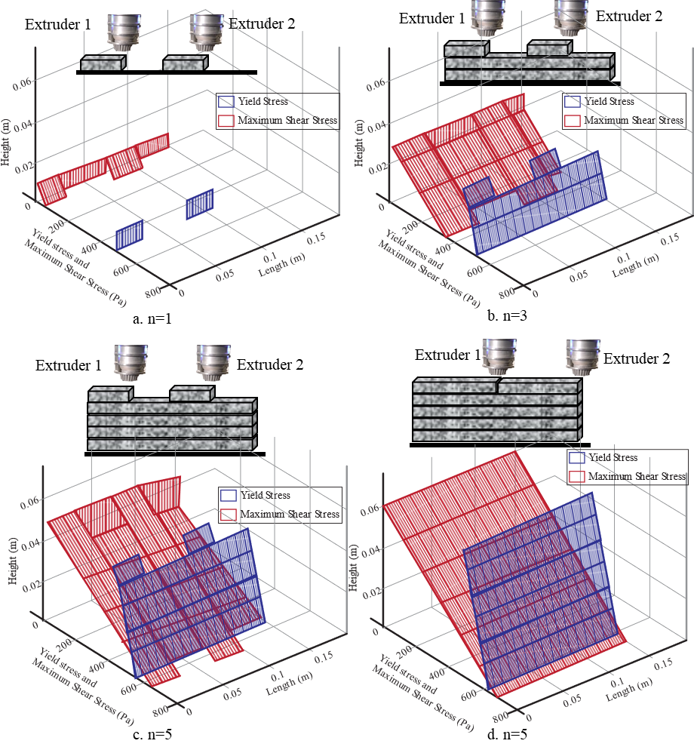
Figure 18. Comparison of yield stress and maximum shear stress for strategy 2 a. n=1, b. n=3, c. start of n=5 and d. completion of n=5 layer.

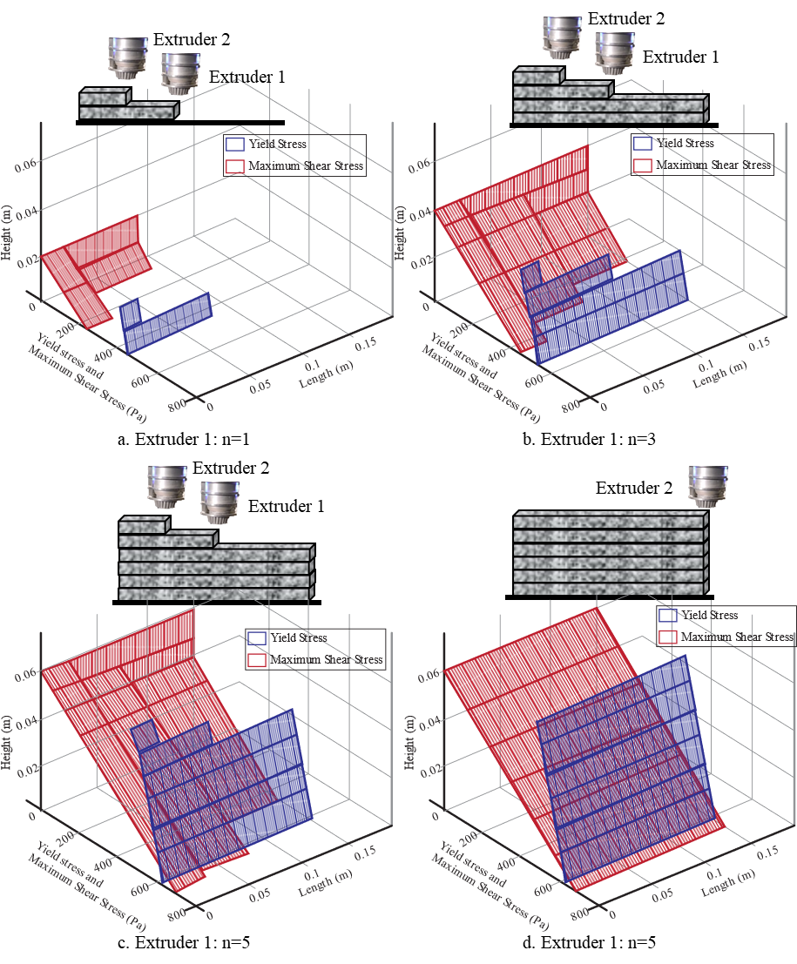
Figure 19. Comparison of yield stress and maximum shear stress for SMLP a. Extruder 1 n=1, b. Extruder 1 n=3, c. Extruder 1 n=5 and d. completion of Extruder 1 as well as extruder 2

3.3.3 Sensitivity Analysis

3.3.3.1 Impact of initial yield stress of concrete
The rheological properties of materials are fundamental in determining the deformation and buildability of parts. Specifically, the initial yield stress of fresh concrete is a controllable parameter that can be enhanced during its preparation. Various methods, such as incorporating accelerators or other additives into the fresh concrete, can be employed to achieve a higher initial yield stress [20]. According to the findings presented in Section 3.2, an increase in the initial yield stress from 500 to 4000 Pa [33,34] affects the time to collapse, as depicted in Figure 20. By elevating the initial yield stress, fresh concrete can bear greater weight and sustain higher build layers before structural failure occurs. Specifically, increasing the initial yield stress from 500 to 4000 Pa resulted in a roughly 600% increase in the number of layers sustained before failure across all strategies. In other words, more layers could be successfully built. Among the strategies, the proposed SMLP strategy (Strategy 3) demonstrated a slight advantage (~3.03%) over Strategy 1 (single-head print), which itself showed better performance (~6.06%) than Strategy 2 (state-of-the-art multi-head print strategy). Furthermore, the benefits of higher initial yield stress became increasingly apparent as the yield stress rose, as shown in Figure 16b. This indicates an improved stress distribution in the proposed cooperative printing approach compared to the state-of-the-art single-head and multi-head printing strategies.
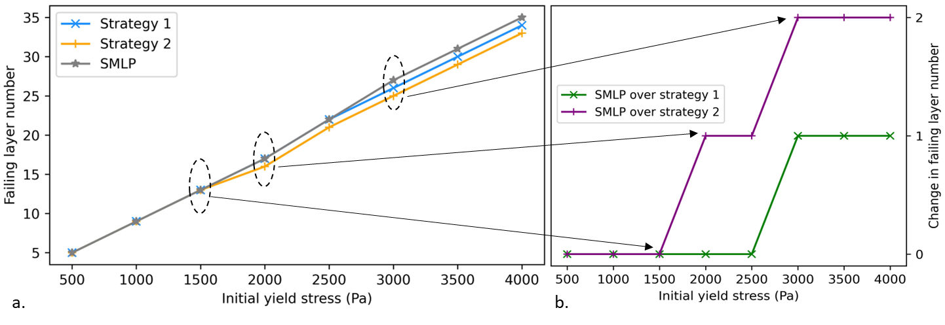
Figure 20. Sensitivity analysis for varying initial yield stress on a. failing layer number (i.e., time of collapse) for all three strategies and b. change in failing layers of SMLP compared to other two strategies

3.3.3.2 Impact of print speed and layer length
The extrusion head speed and wall length were adjusted to assess their influence on both build time and the yield stress of the deposited concrete. Equations to calculate the total build time for all the strategies are provided in the Appendix. In this study, three different speed values, i.e., 25 mm/s, 50 mm/s, and 100 mm/s, were employed. The number of layers was held constant at 5, with a 1-second time gap between the two extruders. In Figure 21, it can be seen that SMLP saves time in compared to strategy 1 and is slower in comparison to strategy 2. As illustrated in Figure 22a, the yield stress development for SMLP very closely follows that of strategy 1, which is widely used in the industry. In addition to that, SMLP achieves higher yield stress value compared to strategy 2 as seen in Figure 22b. Furthermore, among the strategies examined, SMLP fell between strategies 2 and 1 in terms of both build time and yield stress development metrics. Notably, SMLP exhibited closer alignment with strategy 1 in terms of yield stress development and approached strategy 2 in the build time metric. This highlights the advantages inherent in the proposed multi-head printing strategy, making it favorable in real-world applications.
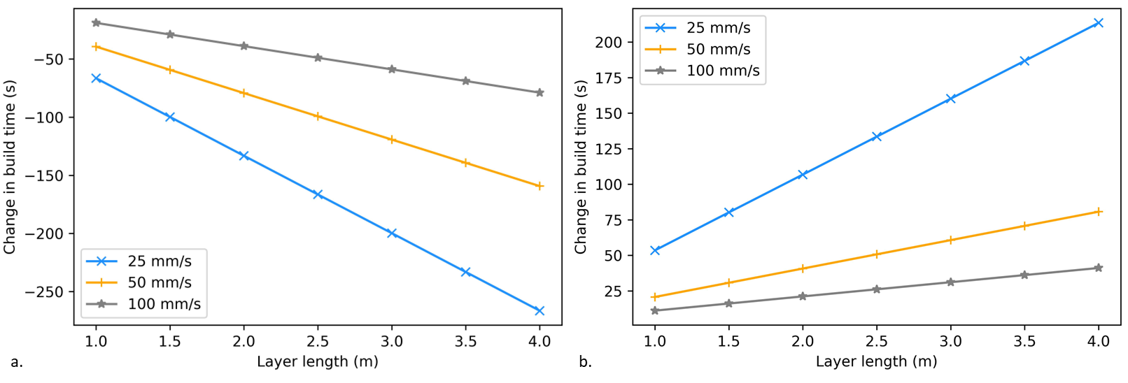
Figure 21. Influence of print speeds on the performance of SMLP compared to a. strategy 1 and b. strategy 2 in build times
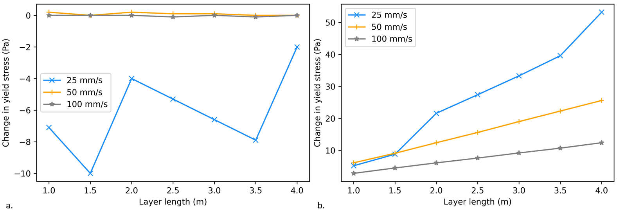
Figure 22. Influence of print speeds on the performance of SMLP compared to a. strategy 1 and b. strategy 2 in yield stress

3.3.3.3 Impact of layer height
The investigation into collapse times for all three strategies across varying layer heights, with a fixed print velocity of 25 mm/s, was explored, as illustrated in Figure 23. As the layer height increases, there is a corresponding increase in the maximum shear stress on the initial layer, resulting in premature failure. Hence, a smaller layer height is preferable across all strategies, regardless of layer length. Among the strategies evaluated, strategy 1, which utilizes a single head, exhibits superior performance across all combinations of layer heights and lengths compared to other strategies. For instance, with a layer length of 4 m and a layer height of 0.01 m, strategies 1, 2, and 3 can print 20, 12, and 16 layers, respectively, before any indication of collapse. In other words, SMLP can build 25% more layers before failing compared to strategy 2. Furthermore, it is noteworthy that the SMLP approach can print a greater number of layers compared to strategy 2 for walls of equivalent length and height.
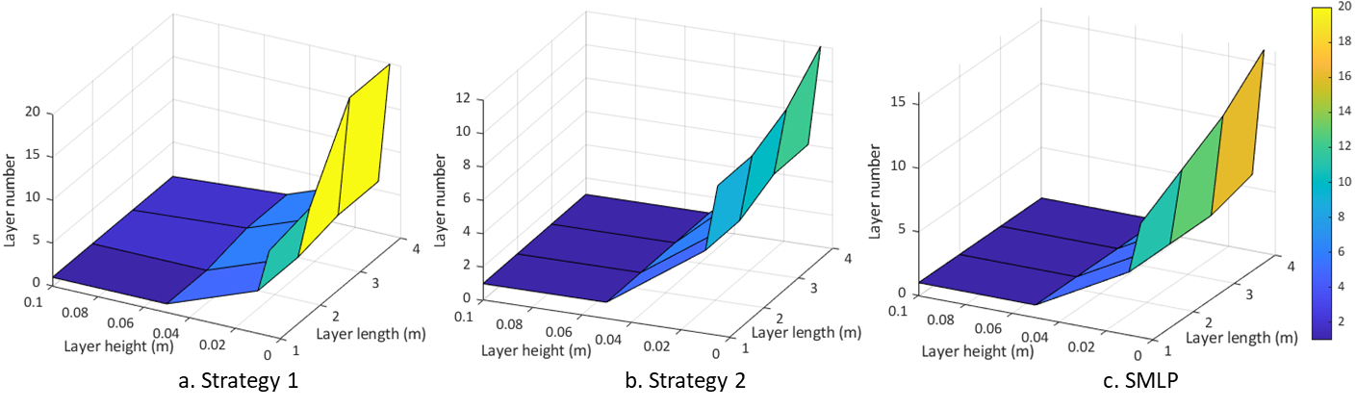
Figure 23. Time of collapse for varying layer height/thickness and layer length for a. strategy 1, b. strategy 2 and c. SMLP

Limitations
The applicability of SMLP is highly dependent on the motion system used. If a traditional gantry-based system is utilized, the printed geometry is generally limited to hollow structures to allow one print head to follow the other without restriction. Complex geometries may require more advanced setups like drones or 6-DOF robotic arms. The implementation on gantry-based system requires specific hardware modifications, such as a customized dual-head mount and separate control boards for each hotend to enable the synchronized delay. SMLP requires higher computational power compared to single-head strategies, specifically to manage collision avoidance between multiple active heads. Coordinated layer wise assignment requires accurate synchronization of two or more heads in space and time and continuous collision avoidance, especially when the heads operate at different heights and pass over previously printed material.On real hardware this translates into more complex motion planners, tighter requirements on calibration, and potentially higher sensitivity to tracking error or communication delays. However, this challenge exists for most of the multi-head printing strategies and not SMLP. Moreover, as the number of heads increases the spacing in height between heads shrinks ,collision risk and coordination complexity grow and non productive travel may increase if all heads must span the entire layer. At some number of heads, the additional speed gain may not justify the extra complexity, especially on gantry systems where all heads share some axes. In future studies, these limitations can be addressed.

Conclusion and Future Work
In this study, a novel decomposition-free cooperative printing strategy, named synchronous multi-layer printing SMLP, is proposed. In SMLP each printing head is assigned to complete individual layers in a coordinated manner, so that consecutive layers are deposited with controlled and nearly uniform inter and intra layer gap times. This design aims to retain the mechanical robustness typically associated with single head printing while achieving build times comparable to conventional multi head strategies.
The proposed strategy was first implemented on a dual head FDM system using PLA, and its performance was compared with a conventional bi directional single head strategy. Tensile and tear tests on printed walls covering a range of printing speeds and spans showed that SMLP can increase strength and reduce variability, particularly at longer spans where inter pass gap times become more critical. These experiments provide rare quantitative evidence that cooperative multi head strategies, when designed to control the age of material at bonding, can improve mechanical performance rather than simply matching single head behavior.
To investigate the implications for extrusion based concrete printing, an analytical model was formulated that couples a time dependent yield stress law with the evolving shear stress distribution in walls printed using SMLP, decomposition based multi head printing, and bi directional single head printing. Collapse was predicted as the time when the maximum shear stress exceeds the local yield stress. The analytical model supports the hypothesis that SMLP can substantially delay collapse and reduce deformation relative to traditional strategies. For the parameter ranges considered, SMLP increased the number of layers that could be built before failure by roughly 100 to 300 percent compared with the decomposition based strategy, and reduced build time by about 24 percent relative to bi directional single head printing. The parametric study further showed that initial yield stress and layer height have the largest influence on collapse time for all strategies. SMLP benefits particularly from higher initial yield stress, where its advantage over other strategies becomes more pronounced. Across strategies, higher initial yield stress, moderate printing speeds that avoid excessive inter pass waiting times, smaller layer heights, and appropriately chosen wall lengths were identified as desirable for enhancing structural integrity.
Overall, the combined experimental and analytical results demonstrate that cooperative printing strategies do not have to trade structural performance for productivity. By explicitly accounting for the interaction between toolpath design, gap times, and material build up, SMLP provides a pathway to faster and more reliable large scale additive manufacturing. Future work will incorporate the explicit effect of interlayer time on bonding strength, extend the framework to more complex geometries and loading scenarios, and further tune coordination among multiple print heads to target specific structural performance and quality requirements. Additionally, investigate different patterns for effect on the mechanical properties and study in detail on microstructural impacts including crack initiation and propagation.

References
[1] Khosravani MR, Haghighi A. Large-Scale Automated Additive Construction: Overview, Robotic Solutions, Sustainability, and Future Prospect. Sustainability 2022;14:9782. https://doi.org/10.3390/su14159782.
[2] Shen H, Pan L, Qian J. Research on large-scale additive manufacturing based on multi-robot collaboration technology. Addit Manuf 2019;30:100906. https://doi.org/10.1016/j.addma.2019.100906.
[3] Roschli A, Gaul KT, Boulger AM, Post BK, Chesser PC, Love LJ, et al. Designing for Big Area Additive Manufacturing. Addit Manuf 2019;25:275–85. https://doi.org/10.1016/j.addma.2018.11.006.
[4] Lowke D, Dini E, Perrot A, Weger D, Gehlen C, Dillenburger B. Particle-bed 3D printing in concrete construction – Possibilities and challenges. Cem Concr Res 2018;112:50–65. https://doi.org/10.1016/j.cemconres.2018.05.018.
[5] Ghungrad S, Mohammed A, Haghighi A. Energy-efficient and quality-aware part placement in robotic additive manufacturing. J Manuf Syst 2023;68:644–50. https://doi.org/10.1016/j.jmsy.2023.05.019.
[6] Tang P, Zhao X, Shi H, Hu B, Ding J, Yang B, et al. A review of multi-axis additive manufacturing: Potential, opportunity and challenge. Addit Manuf 2024;83. https://doi.org/10.1016/j.addma.2024.104075.
[7] Poudel L, Elagandula S, Zhou W, Sha Z. Decentralized and Centralized Planning for Multi-Robot Additive Manufacturing. J Mech Des Trans ASME 2023;145:1–10. https://doi.org/10.1115/1.4055735.
[8] Hasanov S, Alkunte S, Rajeshirke M, Gupta A, Huseynov O, Fidan I, et al. Review on additive manufacturing of multi-material parts: Progress and challenges. J Manuf Mater Process 2022;6. https://doi.org/10.3390/jmmp6010004.
[9] Brackett J, Yan Y, Cauthen D, Kishore V, Lindahl J, Smith T, et al. Characterizing material transitions in large-scale Additive Manufacturing. Addit Manuf 2021;38:101750. https://doi.org/10.1016/j.addma.2020.101750.
[10] Ghungrad S, Haghighi A. Three-dimensional spatial energy-quality map construction for optimal robot placement in multi-robot additive manufacturing. Robot Comput Integr Manuf 2024;88:102735. https://doi.org/10.1016/j.rcim.2024.102735.
[11] Haghighi A, Mohammed A, Wang L. Energy Efficient Multi-Robotic 3D Printing for Large-Scale Construction – Framework, Challenges, and a Systematic Approach. Vol. 2 Manuf. Process. Manuf. Syst. Nano/Micro/Meso Manuf. Qual. Reliab., vol. Volume 2:, American Society of Mechanical Engineers; 2021. https://doi.org/10.1115/MSEC2021-63787.
[12] Wachsmuth JP, Bøhn JH. Multiple Independent Extrusion Heads for Fused Deposition Modeling. Mech Eng 2008;Master of:101.
[13] Poudel L, Sha Z, Zhou W. Mechanical strength of chunk-based printed parts for cooperative 3D printing. Procedia Manuf 2018;26:962–72. https://doi.org/10.1016/j.promfg.2018.07.123.
[14] Krishnamurthy V, Poudel L, Ebert M, Weber DH, Wu R, Zhou W, et al. LayerLock: Layer-Wise Collision-Free Multi-Robot Additive Manufacturing Using Topologically Interlocked Space-Filling Shapes. CAD Comput Aided Des 2022;152:103392. https://doi.org/10.1016/j.cad.2022.103392.
[15] Zhang X, Li M, Lim JH, Weng Y, Tay YWD, Pham H, et al. Large-scale 3D printing by a team of mobile robots. Autom Constr 2018;95:98–106. https://doi.org/10.1016/j.autcon.2018.08.004.
[16] Jin Y an, He Y, Fu J zhong, Gan W feng, Lin Z wei. Optimization of tool-path generation for material extrusion-based additive manufacturing technology. Addit Manuf 2014;1:32–47. https://doi.org/10.1016/j.addma.2014.08.004.
[17] Roussel N. Rheological requirements for printable concretes. Cem Concr Res 2018;112:76–85. https://doi.org/10.1016/j.cemconres.2018.04.005.
[18] Mouser VHM, Melchels FPW, Visser J, Dhert WJA, Gawlitta D, Malda J. Yield stress determines bioprintability of hydrogels based on gelatin-methacryloyl and gellan gum for cartilage bioprinting. Biofabrication 2016;8:035003. https://doi.org/10.1088/1758-5090/8/3/035003.
[19] Buswell RA, Leal de Silva WR, Jones SZ, Dirrenberger J. 3D printing using concrete extrusion: A roadmap for research. Cem Concr Res 2018;112:37–49. https://doi.org/10.1016/j.cemconres.2018.05.006.
[20] Le TT, Austin SA, Lim S, Buswell RA, Gibb AGF, Thorpe T. Mix design and fresh properties for high-performance printing concrete. Mater Struct Constr 2012;45:1221–32. https://doi.org/10.1617/s11527-012-9828-z.
[21] Murata J. Flow and deformation of fresh concrete. Matériaux Constr 1984;17:117–29. https://doi.org/10.1007/BF02473663.
[22] Saak AW, Jennings HM, Shah SP. A generalized approach for the determination of yield stress by slump and slump flow. Cem Concr Res 2004;34:363–71. https://doi.org/10.1016/j.cemconres.2003.08.005.
[23] Duballet R, Gosselin C, Roux P. Additive Manufacturing and Multi-Objective Optimization of Graded Polystyrene Aggregate Concrete Structures. In: Thomsen MR, Tamke M, Gengnagel C, Faircloth B, Scheurer F, editors. Model. Behav., Cham: Springer International Publishing; 2015, p. 225–35. https://doi.org/10.1007/978-3-319-24208-8_19.
[24] Bos F, Wolfs R, Ahmed Z, Salet T. Additive manufacturing of concrete in construction: potentials and challenges of 3D concrete printing. Virtual Phys Prototyp 2016;11:209–25. https://doi.org/10.1080/17452759.2016.1209867.
[25] Nguyen-Van V, Panda B, Zhang G, Nguyen-Xuan H, Tran P. Digital design computing and modelling for 3-D concrete printing. Autom Constr 2021;123:103529. https://doi.org/10.1016/j.autcon.2020.103529.
[26] He L, Chow WT, Li H. Effects of interlayer notch and shear stress on interlayer strength of 3D printed cement paste. Addit Manuf 2020;36:101390. https://doi.org/10.1016/j.addma.2020.101390.
[27] Perrot A, Rangeard D, Pierre A. Structural built-up of cement-based materials used for 3D-printing extrusion techniques. Mater Struct 2016;49:1213–20. https://doi.org/10.1617/s11527-015-0571-0.
[28] Perrot A, Pierre A, Nerella VN, Wolfs RJM, Keita E, Nair SAO, et al. From analytical methods to numerical simulations: A process engineering toolbox for 3D concrete printing. Cem Concr Compos 2021;122:104164. https://doi.org/10.1016/j.cemconcomp.2021.104164.
[29] Jeong H, Han S-J, Choi S-H, Lee Y, Yi S, Kim K. Rheological Property Criteria for Buildable 3D Printing Concrete. Materials (Basel) 2019;12:657. https://doi.org/10.3390/ma12040657.
[30] Papacharalampopoulos A, Bikas H, Foteinopoulos P, Stavropoulos P. A Path Planning Optimization Framework for Concrete Based Additive Manufacturing Processes. Procedia Manuf 2020;51:649–54. https://doi.org/10.1016/j.promfg.2020.10.091.
[31] Li L, Zhang X, Cui W, Liou F, Deng W, Li W. Temperature and residual stress distribution of FGM parts by DED process: modeling and experimental validation. Int J Adv Manuf Technol 2020;109:451–62. https://doi.org/10.1007/s00170-020-05673-4.
[32] Chen Y, Jansen K, Zhang H, Romero Rodriguez C, Gan Y, Çopuroğlu O, et al. Effect of printing parameters on interlayer bond strength of 3D printed limestone-calcined clay-based cementitious materials: An experimental and numerical study. Constr Build Mater 2020;262. https://doi.org/10.1016/j.conbuildmat.2020.120094.
[33] Ivanova I, Mechtcherine V. Effects of volume fraction and surface area of aggregates on the static yield stress and structural build-up of fresh concrete. Materials (Basel) 2020;13. https://doi.org/10.3390/ma13071551.
[34] White C, Lees JM. Yield stress prediction from 3D reconstruction of fresh concrete slump. Cem Concr Res 2023;174:107331. https://doi.org/10.1016/j.cemconres.2023.107331.

Appendix
For strategy 1, if the velocity of nozzle while printing and traversing is $V_{p}$ and $V_{t}$, respectively. The print time for layer $i$ is $L_{i}/V_{p}$ and traverse time between layer $i$ to layer $i+1$ would be $L_{t}/V_{t}$, where $L_{i}$ and $L_{t}$ are the length of printing path and traverse length, respectively. So, the total build time for strategy 1 can be written as:
 | ${TBT}_{1}= \sum_{i}{\left(\frac{L_{p,i}}{V_{p}}\right)+\frac{(n-1)*h}{V_{t}}}$ | (17)
where $h$ is the layer height and is the traversed length by the extruder head in the strategy 1. For strategy 2, the total build time for strategy 2 with $m$ robots can be written as:
 | ${TBT}_{2}= \sum_{i}{\left(\frac{L_{p,i}}{mV_{p}}\right)+\frac{(n-1)*h}{V_{t}}}$ | (18)
In this work, as two extruders are used, the equation will become as,
 | ${TBT}_{2}= \sum_{i}{\left(\frac{L_{p,i}}{2V_{p}}\right)+\frac{(n-1)*h}{V_{t}}}$ | (19)
For SMLP, traverse time will be equal to ${D/V}_{max}$, where $D$ is the distance covered by the head from the end point of current layer to the next start point without any collisions. It is represented by $V_{max}$ and will take less time to reach the start location. The total build time for $m$ extruders can be calculated as,
 | ${TBT}_{3}={\left[\frac{n}{2}\right]}_{c}*\frac{L_{p}}{V_{p}}+{\left[\frac{n-m}{2}\right]}_{c}*\frac{D}{V_{max}}+\left(\left(n+1\right)\%m*t_{d}\right)$ | (20)
where $n$ is the number of layers, ${\left[.\right]}_{c}$ is the ceiling function and $\%$ is a modulo operation. In this work, as two extruders are used, the equation will become as,
 | ${TBT}_{3}={\left[\frac{n}{2}\right]}_{c}*\frac{L_{p}}{V_{p}}+{\left[\frac{n-2}{2}\right]}_{c}*\frac{D}{V_{max}}+\left(\left(n+1\right)\%2*t_{d}\right)$ | (21)

